Chapter 10, Problem 64.

For the circuit shown in Fig. 10.107, find the Norton equivalent circuit at terminals a-b.

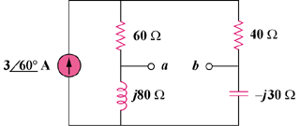

Figure 10.107
For Prob. 10.64.

